**DID Creation**

All the DID get integrated to the DPA file when we do DID integration using CDD file (Given by customer mostly).

In CDD integration, we give CDD file as input to configurator and generate, so that all the DID defined in CDD file get integrated to the DPA file.

If we (Supplier) need to create a new DID other than that provided in the CDD file, we do that in the configurator.

Step 1: Open DPA file in 10_Configuration ( S:\10_Configuration\60_DPA_CONFIG) using Configure BSW in Davinci Configurator

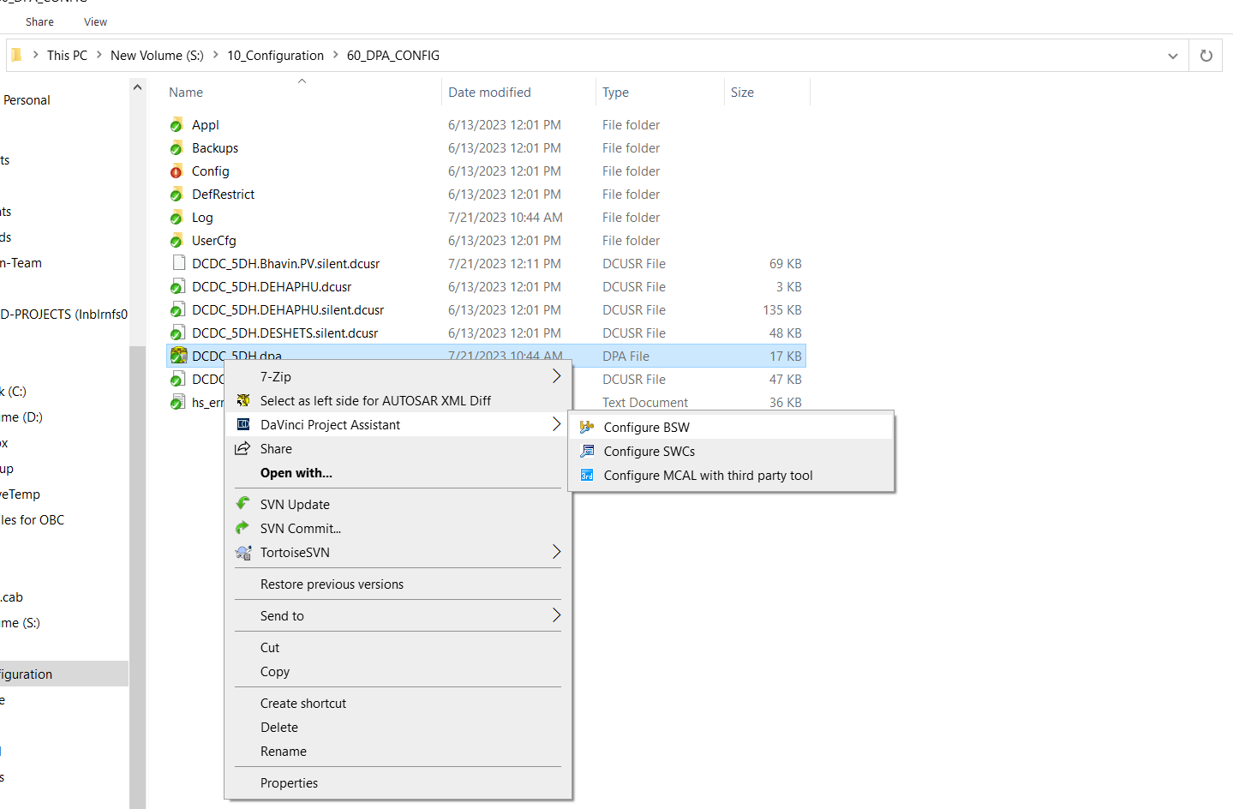

Step 2: Open Basic Editor -> Dcm -> DcmConfigSet -> DcmDsp

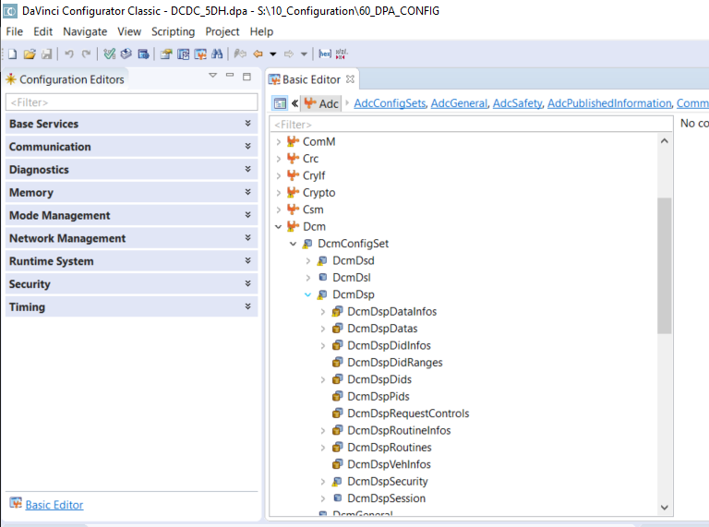

Step 3 : Create Containers in DcmDspDataInfos , DcmDspDatas , DcmDspDidInfos, DcmDspDids

Step 4 : To create in DcmDspDataInfos : Right click on it

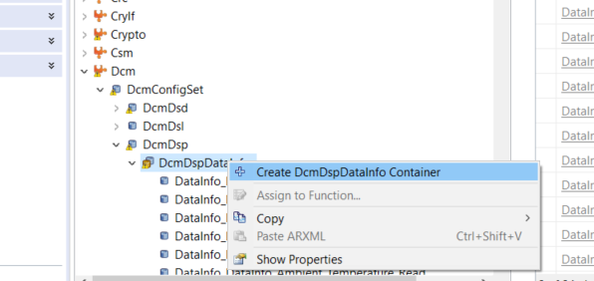

Step 5: Give the name Accordingly

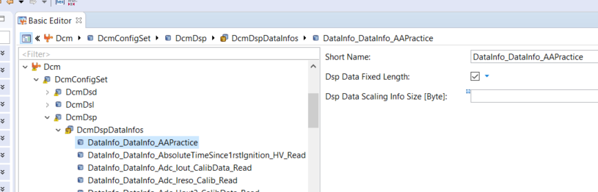

Step 6 : Create DcmDspDatas container similarly , Give reference to datainfo container , Also provide Dsp data size in bit and Dsp Data type as UINT8_N

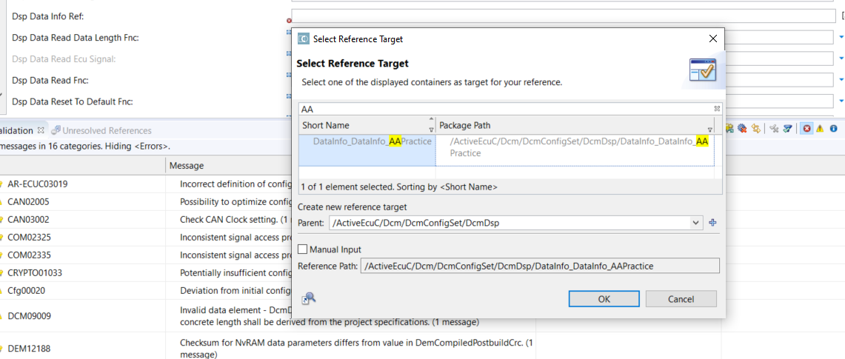

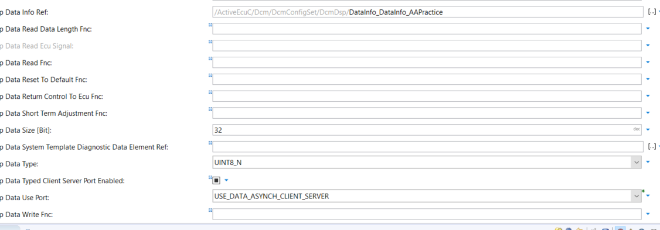

Step 7: Create DcmDspDidInfos Container and name it accordingly

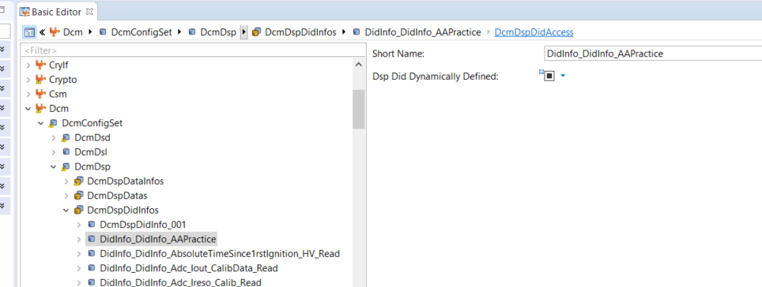

Provide DcmDspDidAccess ,whether to write, read etc

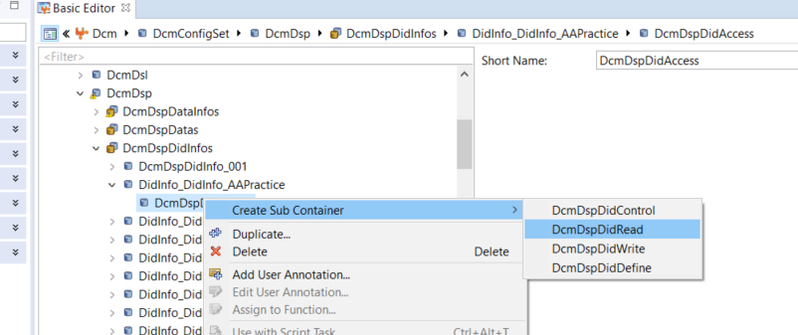

Here you can give in which session you can access the DID if any.

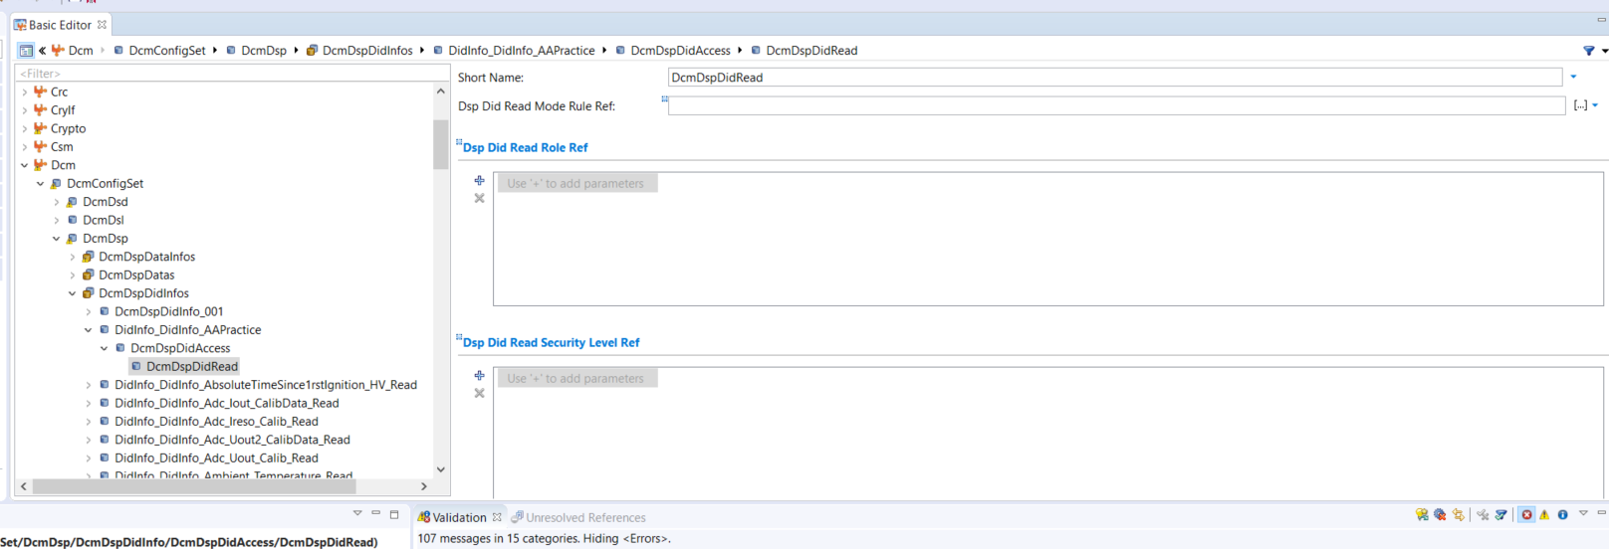

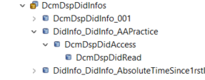

Step 8: Create DcmDspDids Container

Provide name , DID identifier, DidInfo reference of previous Didinfo Container is to be given.

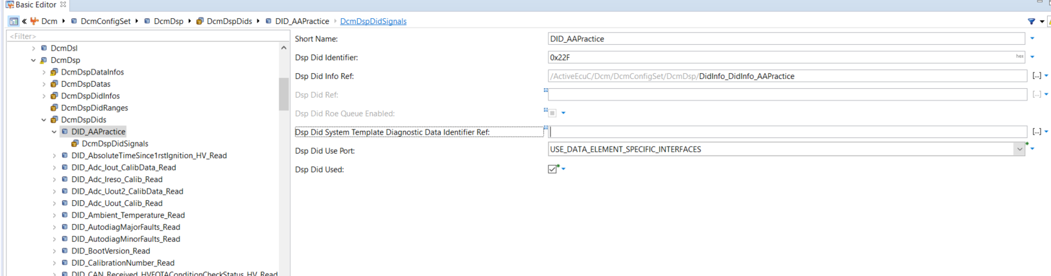

Step 9: Create DcmDspDid Signal Container

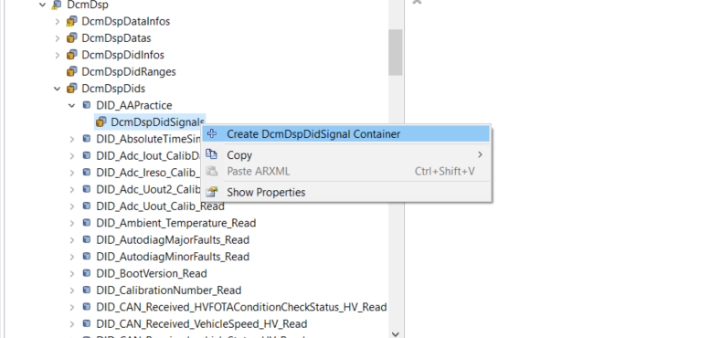

Give reference to DID Created in the signal container Dsp Did Data Ref

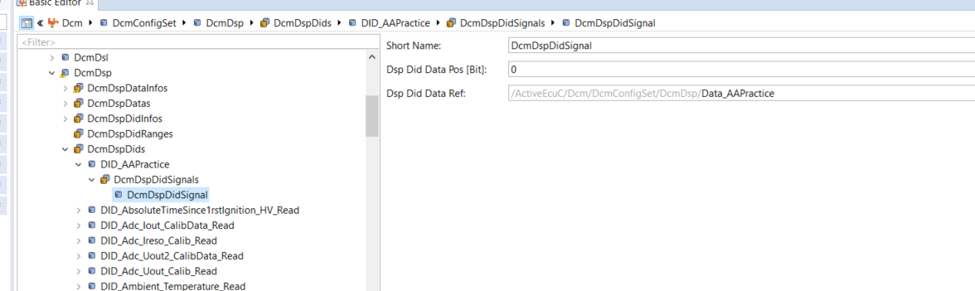

On creating the DID, To check whether its created or not search in Basic Editor with the name

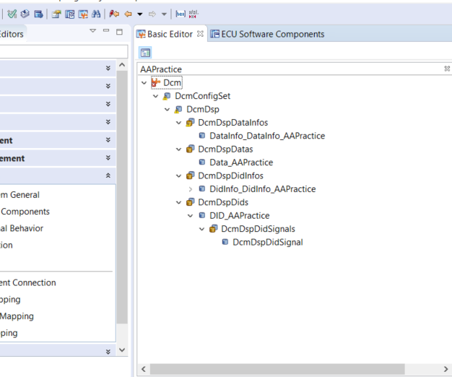

Now Save and Validate Generate.

On Creating the DID, a client port is created in DCM

Search the name of the DID in Runtime system -> ECU Software Components -> Service Components

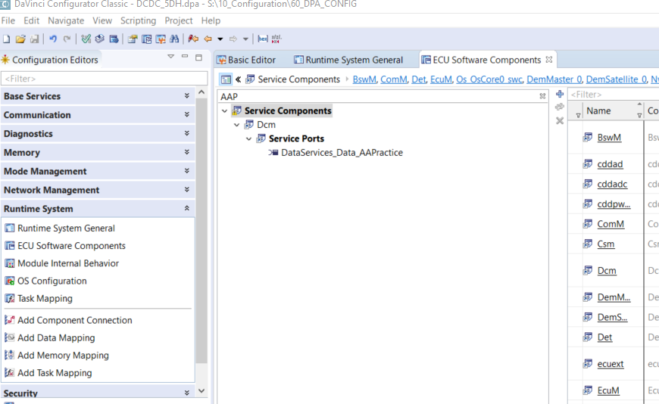

**Creating Server Port in Appldiag**

Step 1: In Developer, Select Appldiag from Object browser -> Application Component Type

Step 2: Service Port -> Port Prototype list

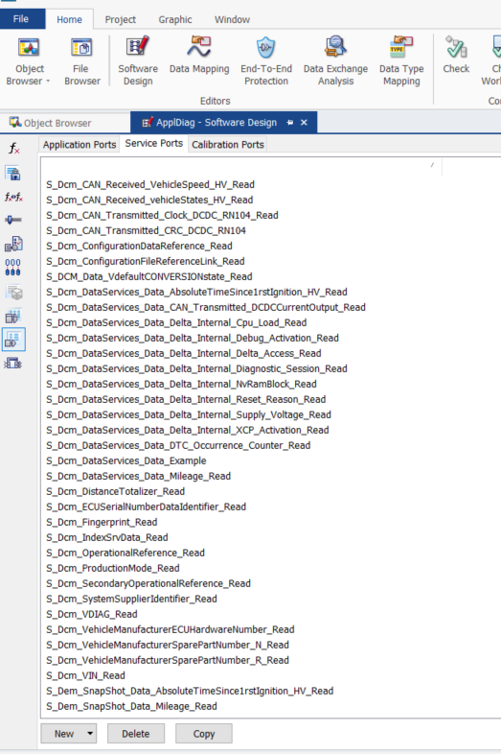

Step 3: Select New -> From Port Interface, Filter by giving the name of Client port interface which in our case (AAPractice)

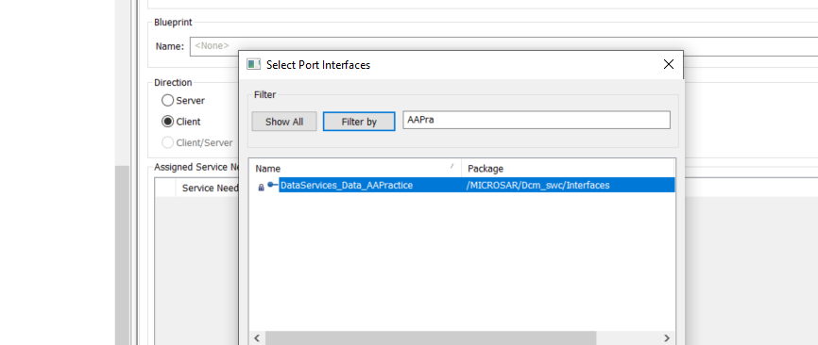

Step 4: Give the name accordingly for the newly created Server port in Appldiag, Select it as Server

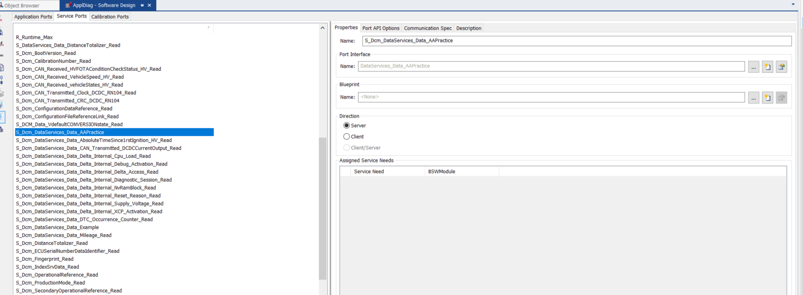

Now a Server port is created in Appldiag

**Creating Server Runnable in Appldiag**

Step 1: Select Runnable entity list in appldiag -> New -> Server Runnable

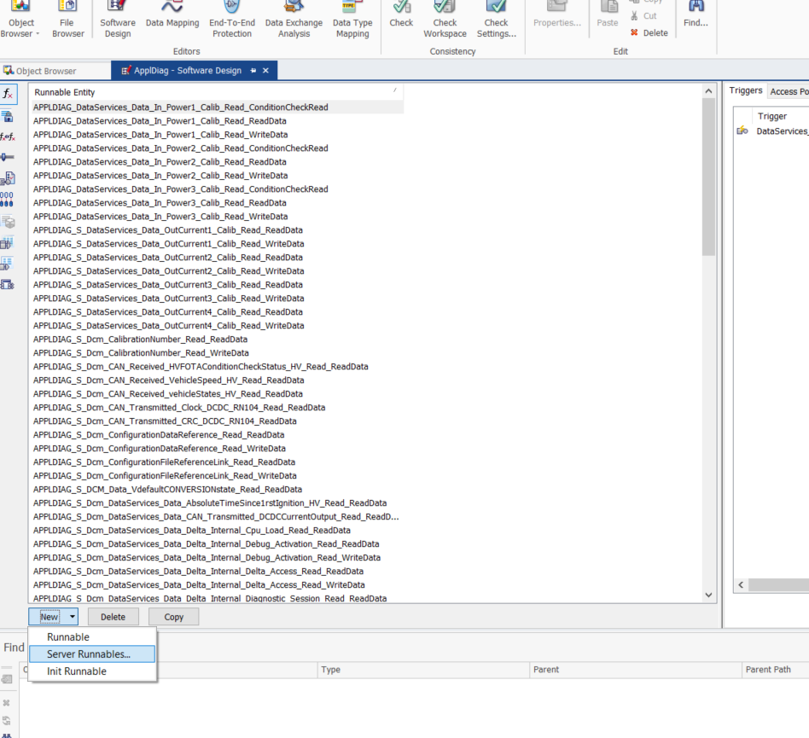

Step 2: Connect the Server Runnable with the Server Port created in Appldiag, which will be by default shown in unhandled server port .

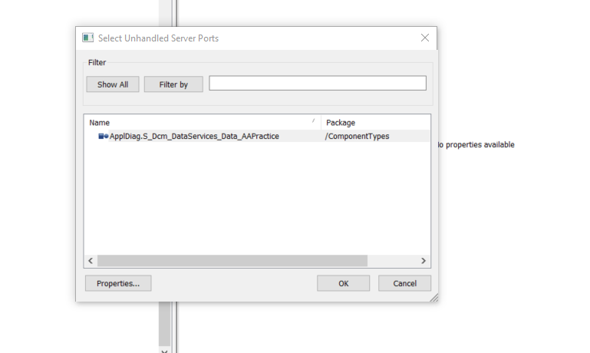

Step 3: Give the Prefix according to the naming followed for other Server runnables

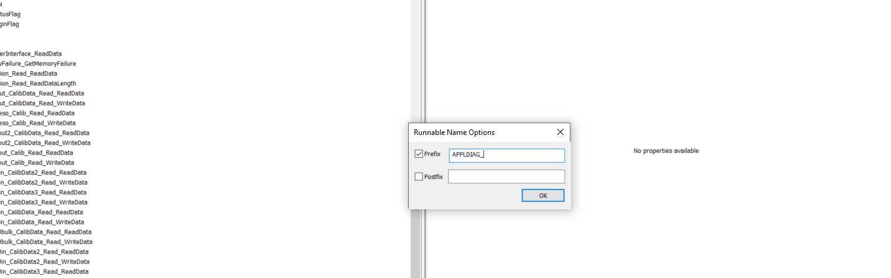

Now two Server runnable will be created

1. Condition check read which used for NRC
2. Read data which we given in the DID access
3. If we need to write data, we need to give DID access while creating DID and it can be seen as created on doing the server runnable creation.

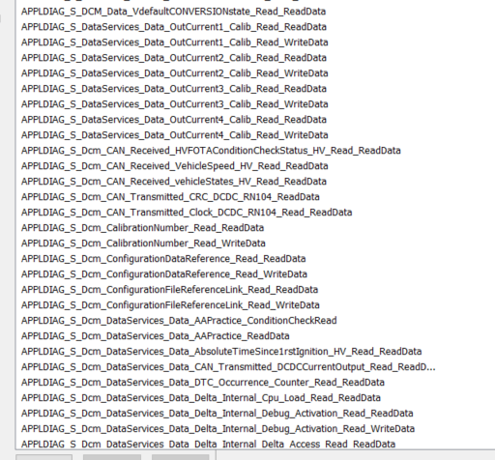

Now the server runnable created will be having the Server port as trigger.

Save Developer.

Step 4 : Now open Configurator and Sync. Now you can see that both server and client port is created.

Search on ECU software components in Runtime system.

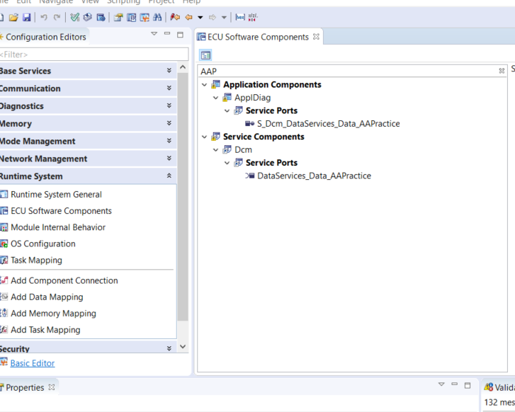

Step 5 : Connect both S and C ports

Runtime system -> Add Component Connection

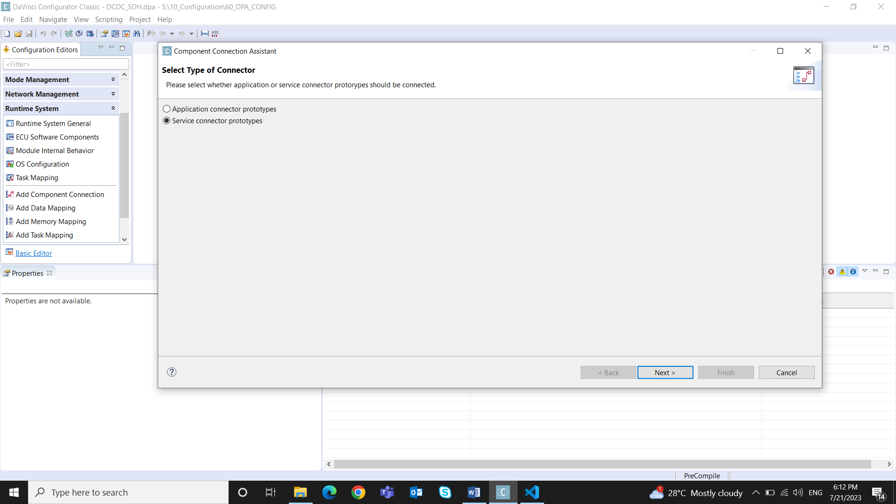

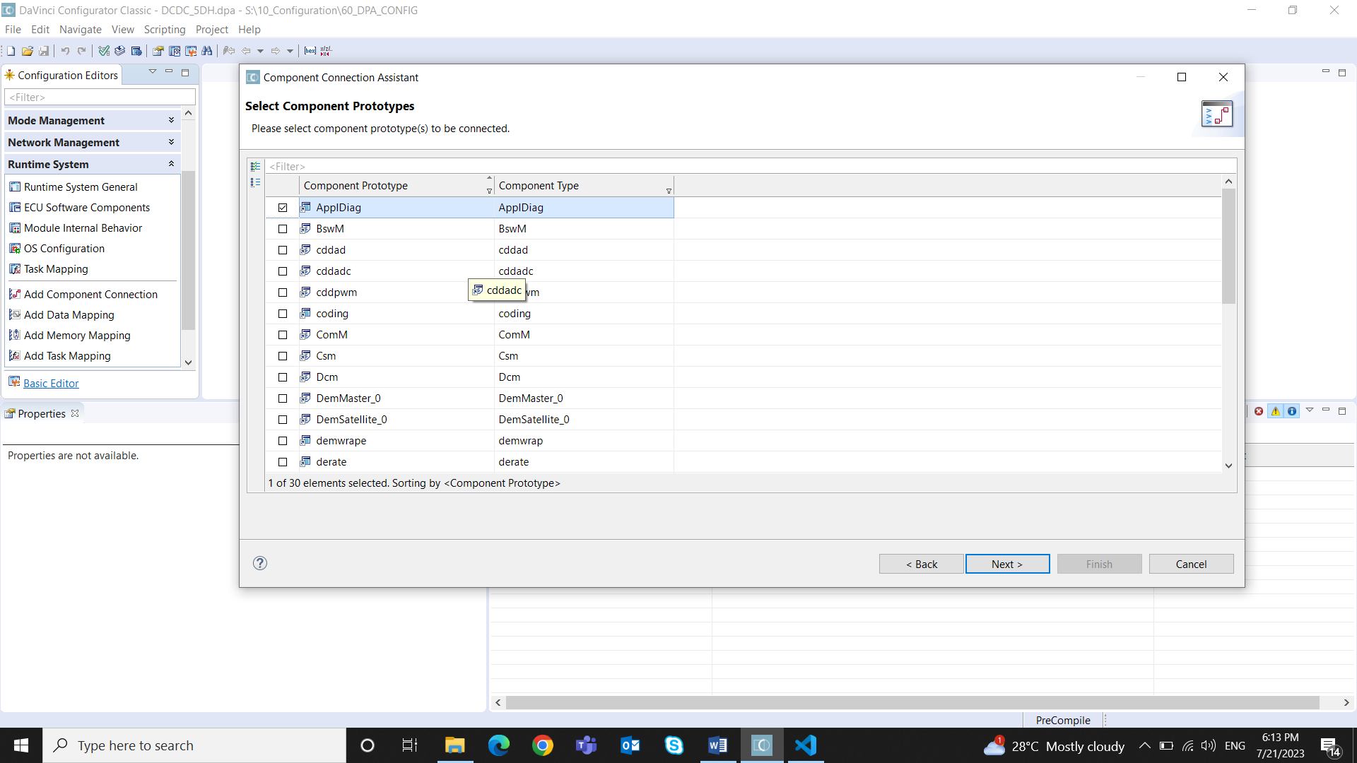

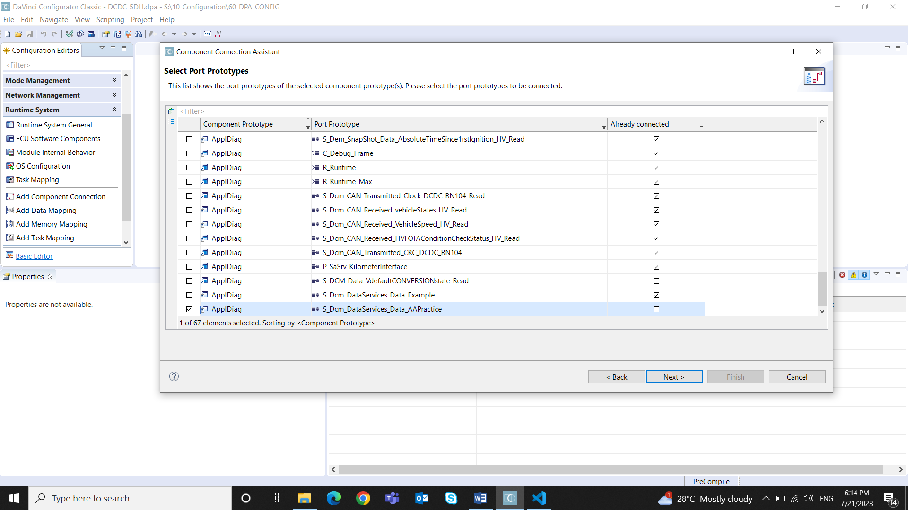

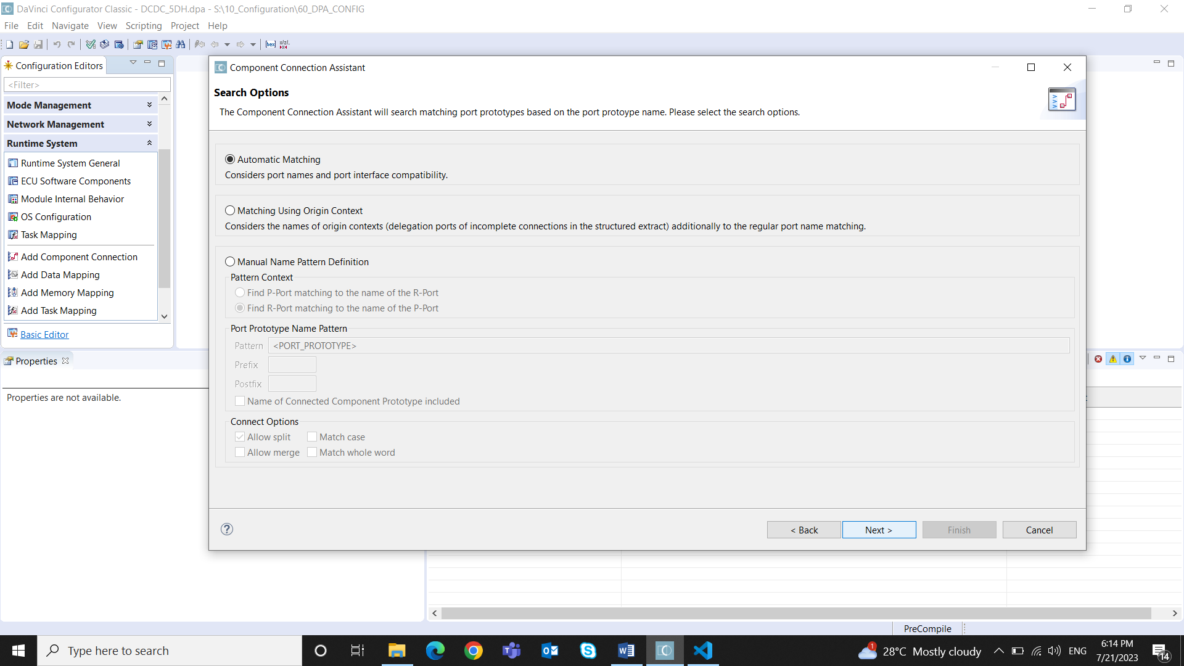

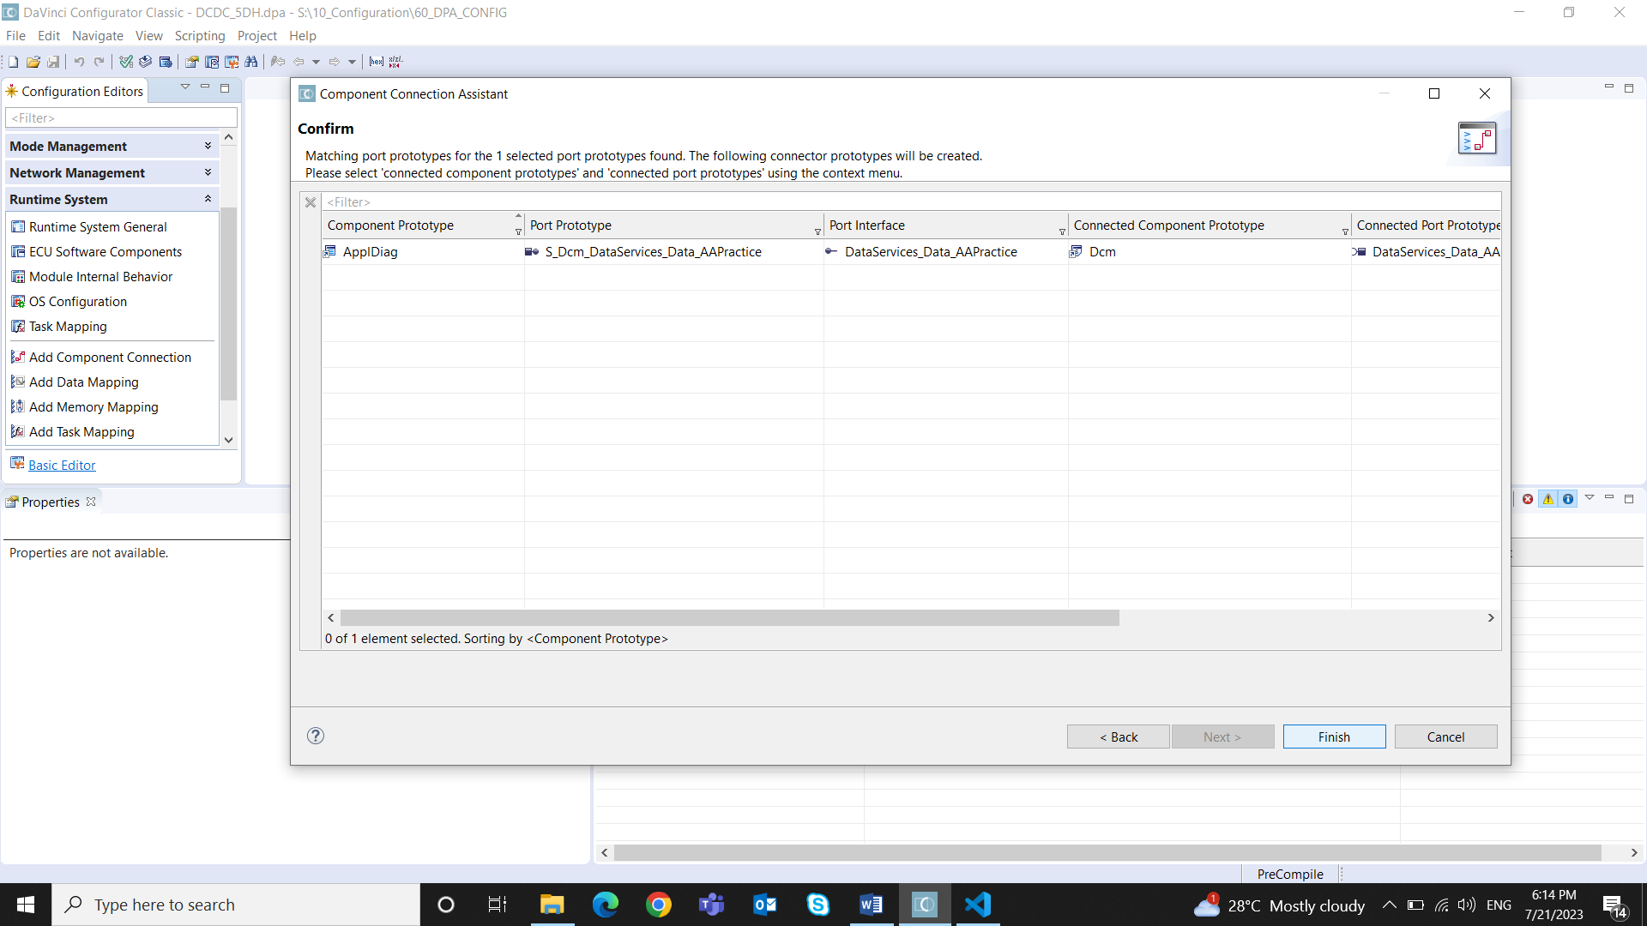

Save

Step 6: Validate and Generate by checking the boxes for the changes made

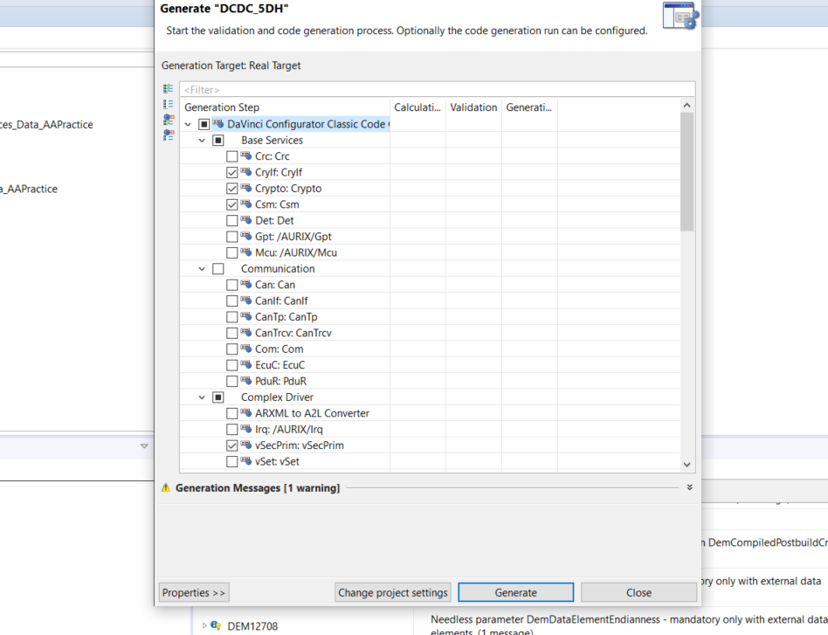

Step 7: Generate SWC templates for the swc for implementing the templates in the c file of appldiag.

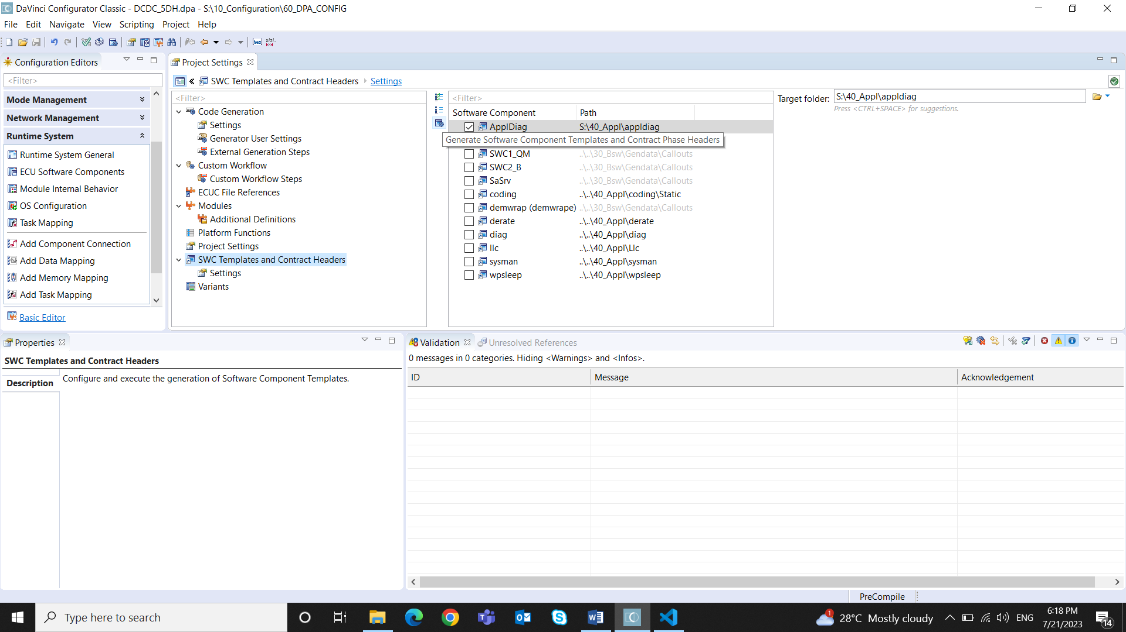

Save in Configurator